Solution Design
Insight Flow

1. Project Goal
Build one AWS data platform that brings together Close CRM leads, Calendly bookings, Wistia video engagement, and marketing spend data. The final dashboard should help connect marketing activity and video engagement with booked meetings and new lead generation.

2. Proposed Architecture
Close CRM and Calendly will arrive in real time through webhooks. Wistia and marketing spend will be loaded on a schedule. Data will be stored in S3, prepared for analysis, queried with Athena, and displayed in Streamlit.

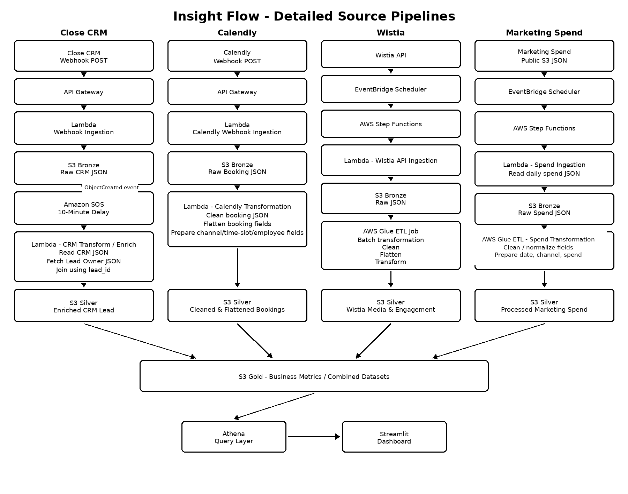
Proposed high-level pipeline architecture

3. Main Data Flow
Close CRM: Close sends new lead events by webhook POST to Amazon API Gateway. API Gateway invokes the webhook-ingestion Lambda, which stores the raw CRM JSON in the S3 Bronze layer. An S3 ObjectCreated event sends a message to Amazon SQS, where a 10-minute delivery delay is applied. After the delay, the CRM transformation/enrichment Lambda reads the CRM JSON, extracts the lead_id, fetches the matching lead-owner JSON from the provided public S3 location, joins the records using lead_id, and writes the enriched CRM lead to the S3 Silver layer. The enriched record is then used for the required Slack/email notification.
Close CRM Webhook POST API URL: https://pfp5p64z5c.execute-api.us-east-2.amazonaws.com/prod/crm
Calendly: Calendly sends booking events by webhook POST to Amazon API Gateway. API Gateway invokes the Calendly webhook-ingestion Lambda, which stores the raw booking JSON in S3 Bronze. A Calendly transformation Lambda then cleans the booking JSON, flattens the nested booking fields, and prepares the booking, channel, time-slot and employee fields needed for analysis. The processed booking records are written to S3 Silver.
Wistia: Amazon EventBridge Scheduler starts the scheduled Wistia batch workflow and AWS Step Functions orchestrates the steps. A Wistia API ingestion Lambda calls the Wistia API and incrementally retrieves new or updated media and visitor-engagement records. The raw API responses are stored in S3 Bronze. An AWS Glue ETL job then performs the Bronze-to-Silver batch transformation by reading the raw JSON files, cleaning the data, flattening nested fields, transforming the required analytics fields, and writing the processed Wistia media and engagement data to S3 Silver.
Marketing Spend: Amazon EventBridge Scheduler starts the scheduled marketing-spend workflow and AWS Step Functions orchestrates the steps. A spend-ingestion Lambda reads the daily JSON from the provided public S3 location and stores the raw spend JSON in S3 Bronze. An AWS Glue ETL job cleans and normalizes the data into fields such as date, channel and spend, then writes the processed data to S3 Silver. The Silver marketing-spend data is later combined with Calendly bookings for metrics such as cost per booking.

4. Data Layers
Bronze - raw JSON received from each source.
Silver - cleaned, flattened and enriched data ready for analysis.
Gold - business metrics and combined datasets used by the dashboard.

5. Simple Data Model
Table | Main Fields | Purpose
crm_leads | lead_id, name, email, lead_owner, funnel, status, created_date | New leads and ownership
calendly_bookings | booking_id, email, event, source, booking_time, employee | Bookings and meeting activity
wistia_media | media_id, title, plays, play_rate, watch_time | Video performance
wistia_visitors | visitor_id, media_id, engagement, event_time | Visitor engagement
marketing_spend | date, channel, spend | Daily campaign spend
The datasets will be connected using identifiers that are actually available, such as email, marketing source/channel, media ID and date. We will not assume one common ID exists across every source.
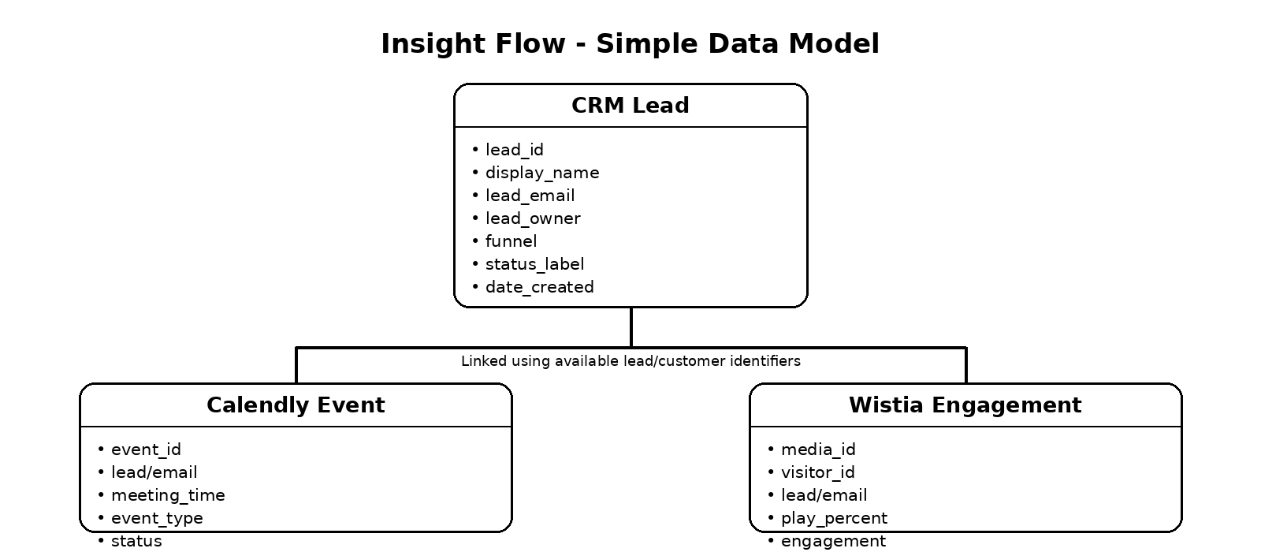

6. Incremental Processing
Wistia: Only new or updated records will be ingested using created_at / updated_at.
Close CRM & Calendly: Webhooks naturally capture new events as they happen, so the pipeline processes incoming events instead of reloading all historical data.
Benefit: This reduces unnecessary reprocessing and helps keep the pipeline efficient and reliable.

7. Final Output
The Streamlit dashboard will combine CRM, Calendly and Wistia insights to show how marketing channels and video engagement relate to bookings and lead generation. Calendly metrics will include daily bookings, cost per booking, booking trends, channel attribution, booking time patterns and employee meeting load.

8. Orchestration & CI/CD
AWS Step Functions will orchestrate the scheduled batch workflow, while Amazon EventBridge Scheduler will trigger Wistia and marketing-spend processing. For Wistia, Lambda handles API ingestion and AWS Glue performs the Bronze-to-Silver batch ETL. Close CRM and Calendly remain event-driven through webhooks, and Amazon SQS provides the required 10-minute CRM delay. GitHub and GitHub Actions will be used for source control and CI/CD.

